Design of Low Pass Filter using Windowing Techniques
4..1. Design and Analysis of an FIR Low-Pass Filter Using the Rectangular Window Technique in MATLAB

Program(MATLAB Code)
clc;
clear;
close all;
%% --- Input Parameters ---
fp = 1000;
% Passband cutoff (Hz)
fs = 4000; % Sampling frequency (Hz)
N = 50; % Filter order (even number preferred)
wc = fp/(fs/2); % Normalized cutoff frequency (0 to 1)
%% --- 1. FIR Low Pass using Rectangular Window ---
b_rect = fir1(N, wc, 'low', rectwin(N+1));
disp('--- Rectangular Window Coefficients ---');
disp(b_rect');
%% --- 2. FIR Low Pass using Hamming Window ---
b_hamm = fir1(N, wc, 'low', hamming(N+1));
disp('--- Hamming Window Coefficients ---');
disp(b_hamm');
%% --- 3. FIR Low Pass using Hanning Window ---
b_hann = fir1(N, wc, 'low', hanning(N+1));
disp('--- Hanning Window Coefficients ---');
disp(b_hann');
%% --- Plot Frequency Responses ---
figure;
freqz(b_rect,1);
title('Low-pass FIR using Rectangular Window');
figure;
freqz(b_hamm,1);
title('Low-pass FIR using Hamming Window');
figure;
freqz(b_hann,1);
title('Low-pass FIR using Hanning Window');

Output:
--- Rectangular Window Coefficients ---
0.0126
0
-0.0137
0
0.0150
0
-0.0166
0
0.0185
0
-0.0210
0
0.0242
0
-0.0286
0
0.0349
0
-0.0449
0
0.0629
0
-0.1048
0
0.3145
0.4940
0.3145
0
-0.1048
0
0.0629
0
-0.0449
0
0.0349
0
-0.0286
0
0.0242
0
-0.0210
0
0.0185
0
-0.0166
0
0.0150
0
-0.0137
0
0.0126
--- Hamming Window Coefficients ---
0.0010
0
-0.0013
0
0.0021
0
-0.0034
0
0.0055
0
-0.0084
0
0.0125
0
-0.0181
0
0.0260
0
-0.0379
0
0.0580
0
-0.1026
0
0.3168
0.4995
0.3168
0
-0.1026
0
0.0580
0
-0.0379
0
0.0260
0
-0.0181
0
0.0125
0
-0.0084
0
0.0055
0
-0.0034
0
0.0021
0
-0.0013
0
0.0010
--- Hanning Window Coefficients ---
0.0000
0
-0.0004
0
0.0013
0
-0.0028
0
0.0050
0
-0.0081
0
0.0122
0
-0.0179
0
0.0259
0
-0.0378
0
0.0580
0
-0.1027
0
0.3172
0.5000
0.3172
0
-0.1027
0
0.0580
0
-0.0378
0
0.0259
0
-0.0179
0
0.0122
0
-0.0081
0
0.0050
0
-0.0028
0
0.0013
0
-0.0004
0
0.0000
Fig 1
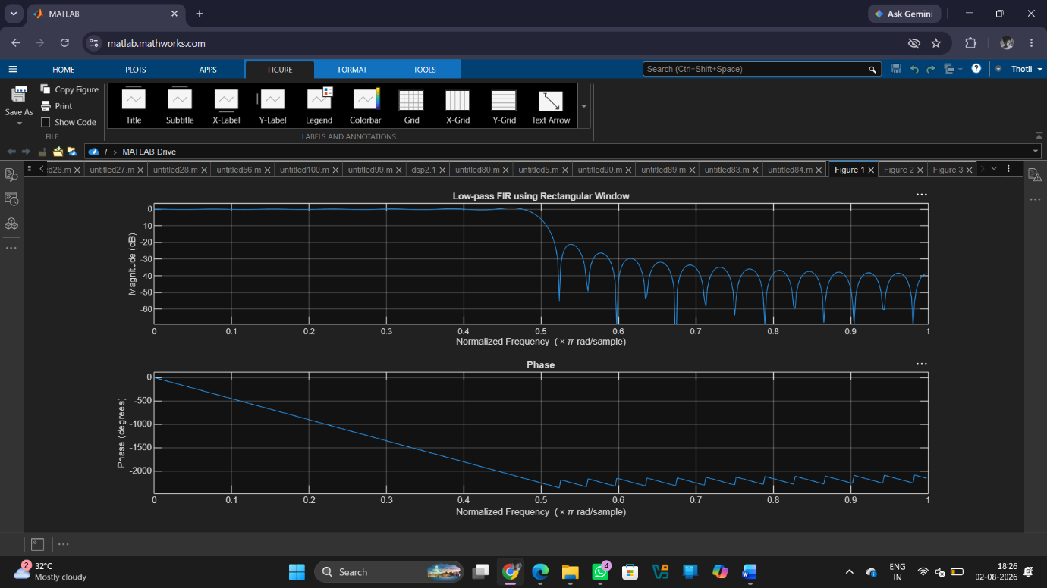
Fig 2
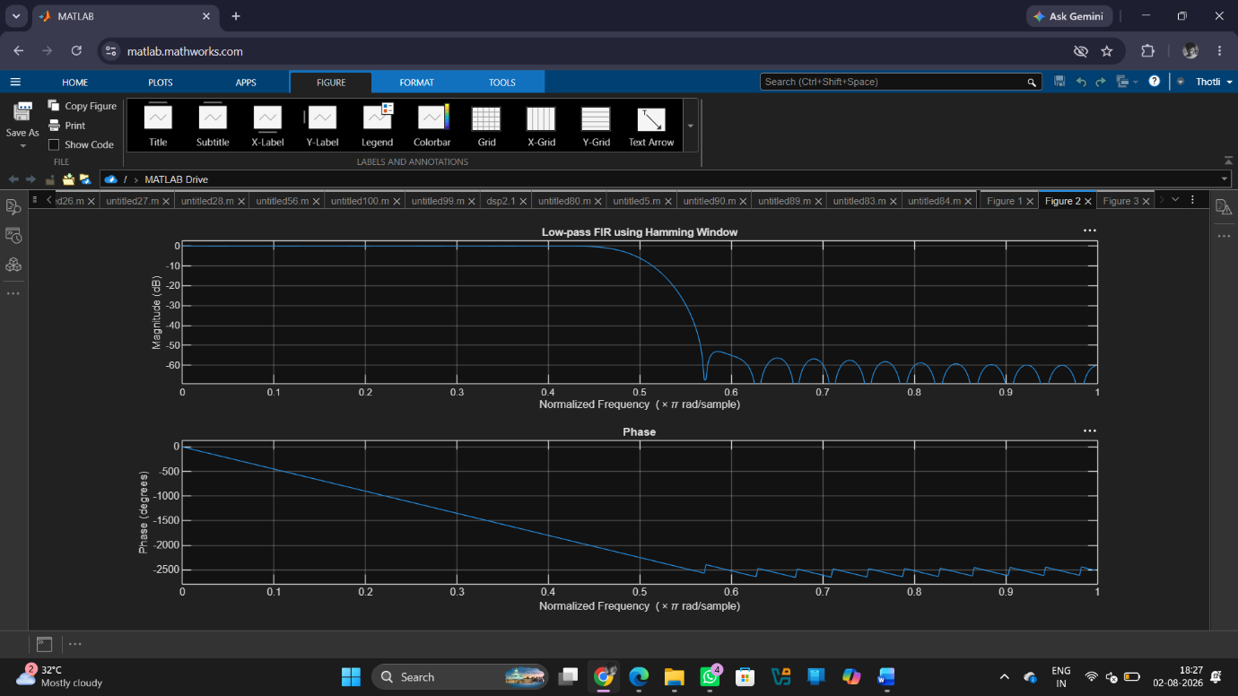
Fig 3
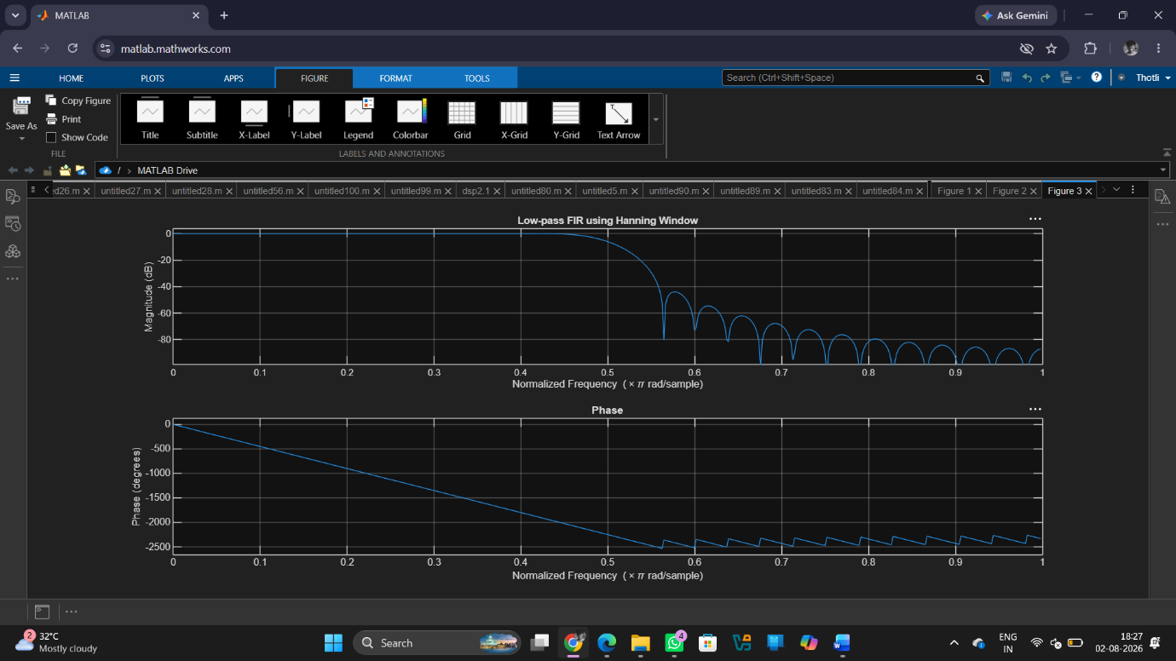
Result:
1. An FIR Low-Pass Filter was successfully designed using the Rectangular Window technique for the specified cutoff frequency, sampling frequency, and filter order.
2. The FIR filter coefficients were successfully generated using MATLAB and the designed filter was implemented.
3. The magnitude response and phase response of the designed FIR Low-Pass Filter were obtained and analysed.
4.The magnitude response exhibited low-pass characteristics, while the phase response demonstrated the expected linear-phase behaviour.

